A java program is needed to be saved by the name of - **“class-name”.java**

To check the version of JAVA installed on your system, you can do this ->

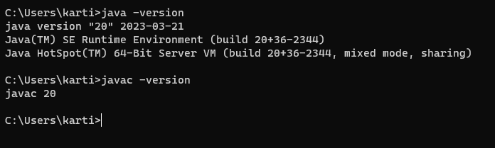

To compile the java code written in Visual Studio or any JRE, you can type ‘javac “class-name”.java

(As you can see in the fig below, our Byte-Code is prepared, which can run very fastly.)

Then type ‘java “class-name”

